CS4052 Computer Graphics

# Introduction

Email: [Rachel.McDonnell@cs.tcd.ie](mailto:Rachel.McDonnell@cs.tcd.ie)

Website: <https://www.scss.tcd.ie/Rachel.McDonnell/IntroCompGraphics.shtml>

We will be using **OpenGL 3 & 4**:

* Don’t read tutorials for older versions as they are no longer relevant.
* Can be written in C, but the object-oriented programming of C++ may be useful.

The coursework-exam split is 20:80%.

Assignments:

* Will be **demonstrated** and **graded** in labs.
* A **report** must be submitted, but will not count towards the grade.

There are three aspects of graphics:

1. **Modelling**: Representing a real object.
2. **Rendering**: Creating an image from a model on a display.
3. **Animation**: Changing the rendering over time.

**Rasterisation** is the process of displaying an image in pixels.

Modelling tools:

* [3ds Max](https://www.autodesk.com/education/free-software/3ds-max) has a free version for academic use (recommended).
* [Blender](https://www.blender.org/) is open-source and has a large community.

This course follows very closely to [Learn OpenGL](https://learnopengl.com/).

# 02a Graphics Programming

A **vertex** is a 3D point $(x,y,z)$.

We can also use $(x,y,z,w)$ which allows vertices and points to be used together.

A triangle:

* Consists of **3 vertices**.
* Has a **normal**.

A **normal** is a vector perpendicular to the triangle which indicates the direction in which it faces. Vertices *can* have normals.

**Rendering** is the process by which a computer creates **images** from **models**.

Representing 3D models:

1. Modelling programs
2. Laser scanning
3. Procedural modelling / generation

A **graphics system** consists of:

1. Input devices
2. CPU (Central Processing Unit)
3. GPU (Graphics Processing Unit)
4. Memory
5. Frame buffer
6. Output devices

### OpenGL (Open Graphics Library)

OpenGL:

* Used for accessing and controlling the **graphics subsystem** of a device
* Device-independent
* Cross-platform
* Only used for **3D** graphics
* Has no platform specifics i.e. windowing, inputs
* C/C++ library

OpenGL uses a **client-server** model:

1. The **application** is the client.
2. The OpenGL on the **graphics card** is the server.

OpenGL behaves like a **state machine**.

### Graphics API Architecture

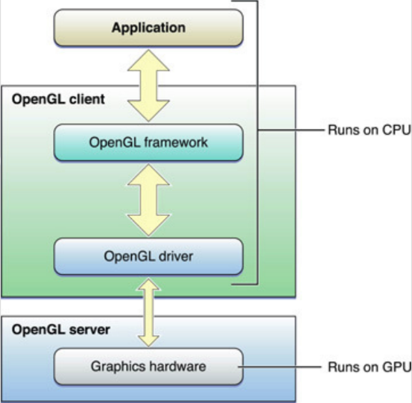

The CPU:

1. Runs **setup** and the **rendering loop**.
2. Copies **mesh data** to **buffers** in the graphics hardware memory.
3. Writes **shaders** to draw on the GPU.
4. Queues drawing on the GPU with a particular shader and mesh data.

The CPU and GPU then run **asynchronously**.

### State Machine

Various aspects of the state machine are set via the API such as:

* Colour
* Lighting
* Blending

When rendering, the **current state** of the state machine is used.

Most parameters are **persistent**, and must be explicitly changed.

### Processing

Commands are always processed in the order in which they are received.

Each primitive is drawn **completely** before any subsequent command takes effect.

### Event-Driven Model

OpenGL is **interactive** and **dynamic**, therefore we must handle interaction from the user.

The **GL library** is the core OpenGL system:

* Modelling
* Viewing
* Lighting
* Clipping

The **GLUT** (GL Utility Toolkit) provides the interface with the **windowing system**:

* Window management
* Menus
* Mouse interaction

### Primitives

GPUs are optimised for points, lines and triangles.

All geometric objects in OpenGL are created from a set of **basic primitives**:

1. **Line-based** primitives:  
   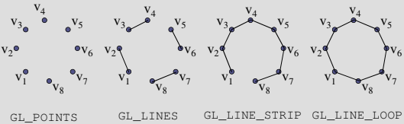
2. **Polygon** primitives:  
   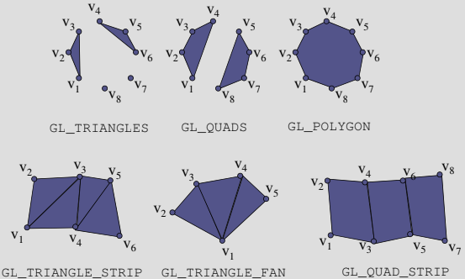

### Conventions

**Function names** begin with gl or glut.

**Constants** begin with GL_, GLU_, or GLUT_.

Function names can encode **parameters** e.g. glVertex2i(1, 3).

### Drawing Process

Typical process:

1. Clear screen
2. Draw scene
3. Complete drawing
4. Swap buffers

In animation, there are usually **two buffers**:

1. Drawing occurs on the **background buffer**.
2. When complete, the background buffer is **swapped** with the front.  
   This gives a smooth animation without the user seeing the drawing.

The technique used to swap the buffers depends on which **windowing library** you use.

### Clearing the Window

| glClearColor(0.0, 0.0, 0.0, 0.0); glClear(GL_COLOR_BUFFER_BIT); |
| --- |

Typically you will clear the **color and depth buffers**:

| glClearColor(0.0, 0.0, 0.0, 0.0); glClearDepth(0.0); glClear(GL_COLOR_BUFFER_BIT | GL_DEPTH_BUFFER_BIT); |
| --- |

You can also clear the **accumulation** and **stencil buffers** with GL_ACCUM_BUFFER_BIT and GL_STENCIL_BUFFER_BIT.

### Specifying a Colour

Colours are specified in RGBA (red, green, blue, alpha) form, in the range $[0-1]$.

### Complete Drawing the Scene

Either glFinish() or glFlush() can be used in OpenGL.

## GLUT (GL Utility Toolkit)

Interaction with the user is handled through an **event loop**.

The application registers **handlers** / **callbacks** to be associated with particular events.

GLUT provides a **wrapper** on the X-Windows or Win32 core event loop, which manages event creation and passing.

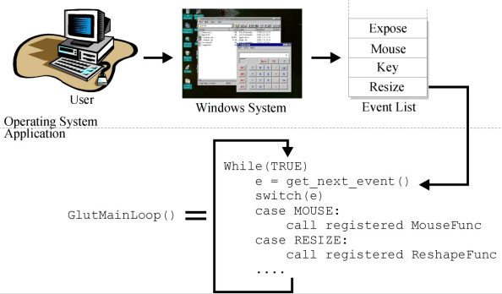

To add handlers for events, we call a **callback-registering function** such as:

| void **glutKeyboardFunc**(void (*func)(unsigned char key, int x, int y)); |
| --- |

This takes a **function** (callback) as a parameter.

Handlers must conform to the specification defined e.g.:

| void **key_handler**(unsigned char key, int x, int y); glutKeyboardFunc(key_handler); |
| --- |

In this case, key is the ASCII code of the pressed key, and (x,y) is the mouse position within the window when the key was hit.

### GLUT Initialisation

| // Pass command-line arguments to GLUT system. glutInit(&argc, argv);  // Enable RGB colour, depth testing and double buffering. glutInitDisplayMode(GLUT_RGBA | GLUT_DEPTH | GLUT_DOUBLE);  // Set window title. glutCreateWindow("RGSquare Application");  // Request for window size (not necessarily accepted). glutReshapeWindow(400, 400); |
| --- |

### GLUT Callback Registration

| // Callback functions void **reshape**(int w, int h) {...} void **keyhit**(unsigned char c, int x, int y) {...} void **idle**(void) {...} void **motion**(int x, int y) {...}  // button = GLUT_UP or GLUT_DOWN. // state = GLUT_LEFT_BUTTON or GLUT_MIDDLE_BUTTON or GLUT_RIGHT_BUTTON. void **mouse**(int button, int state, int x, int y) {...}  // state = GLUT_NOT_VISIBLE or GLUT_VISIBLE void **visibility**(int state) {...}  // value = timer ID void **timer**(int value) {...}  // Register callbacks. glutReshapeFunc(reshape); // On window resize. glutKeyboardFunc(keyhit); // On key press. glutIdleFunc(idle); // On system idle. glutDisplayFunc(draw); // On paint window. glutMotionFunc(motion); // On mouse move. glutMouseFunc(mouse); // On mouse press. glutVisibilityFunc(visibility); // On window deiconify. glutTimerFunc(timer); // On timer elapse. |
| --- |

### Sample Program: Triangles

| int **main**(int argc, char** argv) {  // Create a window using GLUT.  glutInit(&argc, argv);  glutInitDisplayMode(GLUT_RGBA);  glutInitWindowSize(512, 512);  glutInitContextVersion(4, 3);  glutInitContextProfile(GLUT_CORE_PROFILE);   // Create window with its name.  glutCreateWindow(argv[0]);   if (glewInit()) {  cerr << "Unable to initialise GLEW... exiting" << endl;  exit(EXIT_FAILURE);  }   init();   glutDisplayFunc(display);   // Start event loop.  glutMainLoop(); } |
| --- |

| void **init**(void) {  // Setup object's initial position.  glGenVertexArrays(NumVAOs, VAOs);  glBindVertexArray(VAOs[Triangles]);   GLfloat vertices[NumVertices][2] = {  // Triangle 1.  { -0.90, -0.90 },  { 0.85, -0.90 },  { -0.90, 0.85 },   // Triangle 2.  { 0.90, -0.85 },  { 0.90, 0.90 },  { -0.85, 0.90 },  };   glGenBuffers(NumBuffers, Buffers);  glBindBuffer(GL_ARRAY_BUFFER, Buffers[ArrayBuffer]);  glBufferData(  GL_ARRAY_BUFFER, sizeof(vertices), vertices, GL_STATIC_DRAW  );   // Specify shaders.  ShaderInfo shaders[] = {  { GL_VERTEX_SHADER, "triangles.vert" },  { GL_FRAGMENT_SHADER, "triangles.frag" },  { GL_NONE, NULL }  };   GLuint program = loadShaders(shaders);  glUseProgram(program);   glVertexAttribPointer(  vPosition, 2, GL_FLOAT, GL_FALSE, 0, BUFFER_OFFSET(0)  );  glEnableVertexAttribArray(vPosition); } |
| --- |

| void **display**(void) {  glClear(GL_COLOR_BUFFER_BIT);   // Pick current vertex array.  glBindVertexArray(VAO[Triangles]);  glDrawArrays(GL_TRIANGLES, 0, NumVertices);   // Request image to be presented on screen.  glFlush(); } |
| --- |

### Programmable Pipeline

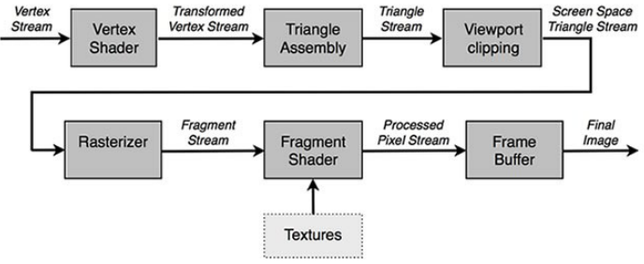

## Shaders

OpenGL used to be fixed, but is now shader-based.

A **shader**:

* A program with main as its entry point.
* Source code is a **text file**.
* Written in Cg, HLSL or GLSL.

### GLSL (OpenGL Shading Language)

GLSL:

* C-like language.
* Compiled into a program at runtime.
* We get back IDs which are ints.

Data types:

* Scalar types:  
  float, int, bool
* Vectors types:  
  vec2, vec3, vec4
* Matrix types:  
  mat2, mat3, mat4

Texture sampling:

sampler1D, sampler2D, sampler3D, samplerCube

C++ style constructors:

| vec3 a = vec3(1.0, 2.0, 3.0); |
| --- |

#### Operators

GLSL uses standard C/C++ arithmetic and logic operators.

These are overloaded for **matrix** and **vector** operations:

| mat4 m; vec4 a, b, c;  b = a * m; c = m * a; |
| --- |

#### Components

**Vector components** can be accessed using either:

1. Array indexing: []
2. Named components: xyzw, rgba or stpq.

| vec3 v; |
| --- |

v[1], v.y, v.g and v.t all refer to the **same** element.

#### Qualifiers

Vertex attributes and other variable info can be copied in and out of shaders:

| in vec2 textureCoord; out vec4 color; |
| --- |

The uniform keyword declares a shader **constant** variable.

This value does not change between vertices / fragments:

| uniform float time; uniform vec4 rotation; |
| --- |

### Shader Types

There are two primary types of shader:

1. **Vertex** shader:
   * Changes the **position** of a vertex (e.g. translation, rotation, skew).
   * *May* determine the colour of a vertex.
2. **Fragment** shader:
   * Determines the **colour** of a **pixel**.
   * Uses lighting, materials, normals etc.

**Vertex** shaders:

* Process vertices.
* Must **always** output a **vertex location**.
* Usually transform vertices into **homogeneous clip space**.

The data describing what triangles are formed is **not** available to the vertex shader.

**Vertex shader outputs** become **pixel shader inputs**.

**Fragment / pixel shaders**:

* Can be passed a total of **16 vectors** from the vertex shader.
* Can only influence the fragment handed to it:
  + Cannot send its results directly to neighbouring pixels.
  + Uses the data **interpolated** from the vertices along with stored constants and texture data.

There are other ways to affect neighbouring pixels.

[Shadertoy](https://www.shadertoy.com/) is a useful WebGL tool for experimenting with shaders on the fly.

### Making a Shader Program

Steps:

1. Compile a **vertex shader** ⇒ get ID.
2. Compile a **fragment shader** ⇒ get ID.
3. **Link** those two shaders together ⇒ get ID.

The final ID should be used before rendering triangles.

You can use **separate shaders** for each model.

Examples:

| in vec4 vPosition;  void **main**() {  // The value of vPosition should be between -1.0 and 1.0.  gl_Position = vPosition; } |
| --- |
| out vec4 fColor;  void **main**() {  // Colour the pixel red.  fColor = vec4(1.0, 0.0, 0.0, 1.0); } |

### Compiling Shaders

| <GLuint> glCreateShader(<type>) |
| --- |

* **Creates an ID** (a GLuint) of a shader.
* e.g. GLuint ID = glCreateShader(GL_VERTEX_SHADER);

| glShaderSource(<id>, <count>, <src code>, <lengths>) |
| --- |

* **Binds the source code** to the shader.
* Occurs **before compilation**.

| glCompileShader(<id>) |
| --- |

* Used to make the shader program.

### Creating / Linking / Using Shaders

| <GLuint> glCreateProgram() |
| --- |

* Returns an ID that should be stored for the life of the program.

| glAttachShader(<prog ID>, <shader ID>) |
| --- |

* Do this for both the **vertex** and **fragment shaders**.

| glLinkProgram(<prog ID>) |
| --- |

* Actually makes the shader program.

| glUseProgram(<prog ID>) |
| --- |

* Use this shader when you’re about to draw triangles.

|  |
| --- |
|  |
|  |

## Vertex Buffer Objects

How do we get the geometry & colour onto the GPU?

Typically we also need a **normal** and **texture coordinate** for each vertex.

We ask the OpenGL driver to create a **buffer object**:

* Chunk of **memory** e.g. array.
* Located on the **GPU**.

### Working with Buffers

To create a **buffer ID**:

| // This will be the ID of the buffer. GLuint buffer;  // Ask OpenGL to generate exactly 1 unique ID. glGenBuffers(1, &buffer); |
| --- |

To set the buffer as the **active** one and specify which buffer we’re referring to:

| glBindBuffer(GL_ARRAY_BUFFER, buffer); |
| --- |

Notes:

* The buffer is now **bound** and **active**.
* Any **drawing** will come from that buffer.
* Any **loading** will go into that buffer.

### Loading the Buffer with Data

We want to store an array data in the GPU:

| glBufferData(GL_ARRAY_BUFFER, sizeof(data), data, GL_STATIC_DRAW); |
| --- |

GL_<freq>_<mode>:

* <freq> = STREAM / STATIC / DYNAMIC (How frequently the data will change)
* <mode> = DRAW / READ / COPY

Process:

1. **Create the buffer** and pass **no data**.
2. Load the **geometry**.
3. Load the **colours**.
4. Load the **normals**, **texture coordinates** etc.

Buffers can be organised in any way.

| // vertices = (x,y,x), colours = (r,g,b,a) generateObjectBuffer(GLfloat vertices[], GLfloat colours[]) {  // Vertex buffer object.  GLuint VBO;  glGenBuffers(1, &VBO);  glBindBuffer(GL_ARRAY_BUFFER, VBO);  glBufferData(  GL_ARRAY_BUFFER,  numVertices * 7 * sizeof(GLfloat), // verts + colours = 7  NULL, // Load no data.  GL_STATIC_DRAW  );  glBufferSubData(  GL_ARRAY_BUFFER,  0,  numVertices * 3 * sizeof(GLfloat), // vertices  vertices  );  glBufferSubData(  GL_ARRAY_BUFFER,  numVertices * 3 * sizeof(GLfloat),  numVertices * 4 * sizeof(GLfloat), // colors  colours  ); } |
| --- |

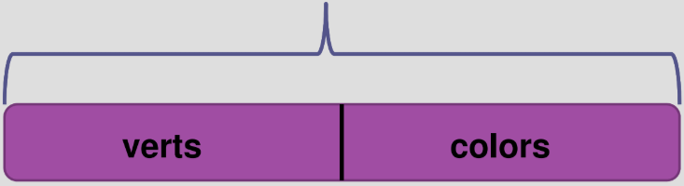

At the moment we have a buffer which:

* Has an ID.
* Lives on the graphics card.
* Is full of vertex position / colour data.

Buffer information needs to be passed to our **shader**.

### Link to Shader

| in vec4 vPosition; in vec4 vColor; out vec4 color;  void **main**() {  gl_Position = s_vPosition;  Color = vColor; } |
| --- |

We need to **query the shader program** for its variables:

| // Get vPosition ID. GLuint vpos = glGetAttribLocation(programID, "vPosition"); |
| --- |

In OpenGL, we must **enable attributes**:

| // Turn on vPosition. glEnableVertexAttribArray(vpos); |
| --- |

Tell variables where to find their info in the currently-bound buffer:

| void **glVertexAttribPointer**(  GLuint index,  GLint size,  Glenum type,  GLboolean normalized,  GLsizei stride,  const GLvoid* offset ); |
| --- |
| // Bind the variable to a spot in the buffer.  glVertexAttribPointer(  vpos,  3,  GL_FLOAT,  GL_FALSE,  0,  0 // Where to find variable in buffer.  ); |

| cpos = glGetAttribLocation(programID, "vColor"); glEnableVertexAttribArray(cpos); glVertexAttribPointer(  cpos, // Attribute location.  4, // Size of data.  GL_FLOAT, // Type of data.  GL_FALSE,  0,  BUFFER_OFFSET(numVertices * 3 * sizeof(Glfloat)) // Data offset. ); |
| --- |

### Index Buffers

An index buffer allows you to create an object which reuses the same vertices.

|  |  |
| --- | --- |

| GLuint ebo; glGenBuffers(1, &ebo); glBindBuffer(GL_ELEMENT_ARRAY_BUFFER, ebo); glBufferData(GL_ELEMENT_ARRAY_BUFFER, size, indices, GL_STATIC_DRAW); |
| --- |

To render the triangles, instead of using glDrawArrays, use:

| glDrawElements(GL_TRIANGLES, numIndices, GL_UNSIGNED_INT, NULL); |
| --- |

### VAOs (Vertex Array Objects)

* Pure State: It remembers almost everything about buffers.
* Set it up once, then call it before drawing.
* glVertexAttribPointer();
* Does **not** bind the VBO.

VAOs allow us to bind multiple related VBOs at once.

Creating a vertex array object:

| // This will be the ID of the VAO. GLuint vao;  // Ask the driver for exactly 1 unique ID. glGenVertexArrays(1, &vao);  // Everything after this will be a part of the VAO. glBindVertexArray(vao); |
| --- |

### Uniforms

**Uniform data** passed into a shader **stays the same** for each fragment e.g. transformation matrix.

Get data directly from the application to shaders.

Two approaches:

1. Declare in default block.
2. Store in a buffer object.

Simply place the keyword uniform at the beginning of the **variable definition**.

| in vec4 vPosition; // The vertex in local coordinate system. uniform mat4 mM; // The matrix for the pose of the model. uniform mat4 mV; // The matrix for the pose of the camera. uniform mat4 mP; // The projection matrix (perspective).  void **main**() {  gl_Position = mP * mV * mM * vPosition; } |
| --- |

# 02b Graphics Pipeline

**Old** versions of OpenGL used a **fixed-function** pipeline:

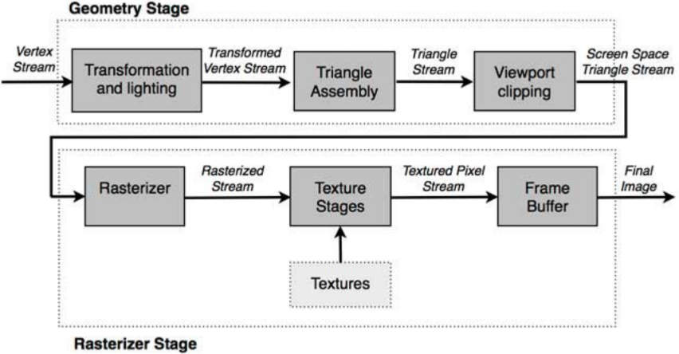

However, in the newer versions of OpenGL, a **programmable** pipeline is used.

### Programmable Pipeline

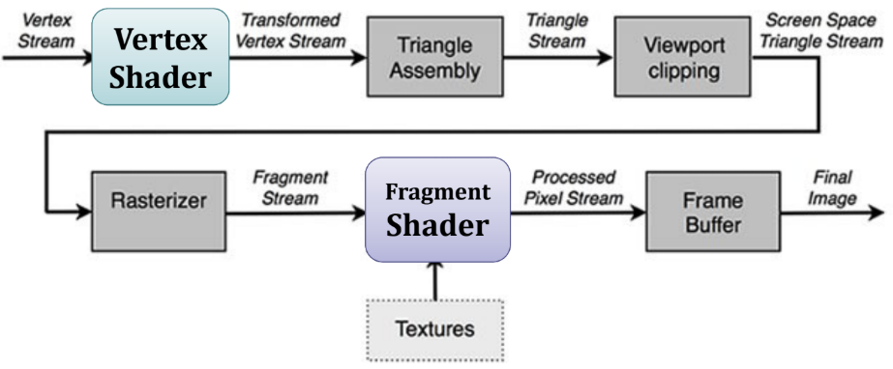



Each stage of the pipeline is a pipeline in itself.

The **slowest pipeline stage** determines the rendering speed (FPS).

### Application Stage

The developer has **full control** of the application stage.

It is executed on the **CPU**.

At the end of the application stage, the rendering **primitives** are fed to the **geometry stage**.

### Geometry Stage

This stage is responsible for the **per-polygon** and **per-vertex** operations.

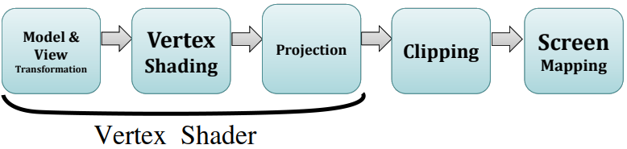

#### 1) Model & View Transformation

Models are transformed into several spaces or **coordinate systems**.

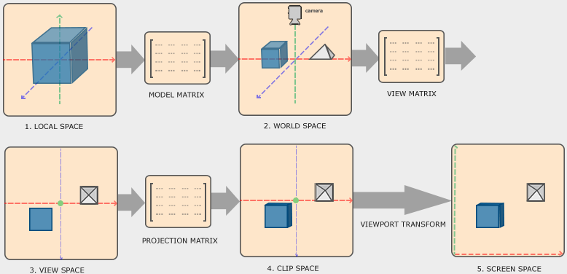

#### 2) Vertex Shading

**Shading** determines the effect of a **light** on a material.

A variety of **material data** can be stored at each vertex:

* Point location
* Normal
* Colour

**Vertex shading results** (colours, vectors, texture coordinates) are sent to the **rasterisation stage** to be **interpolated**.

#### 3) Projection

| After shading, rendering systems perform **projection**.  Models are projected from three dimensions to two.  This uses **perspective** or **orthographic** viewing. |  |
| --- | --- |

#### 4) Clipping

Memory may contain models, textures and shader data for **all** objects in a scene.

The virtual camera viewing the scene only sees the objects **within the field of view**.

The computer does not need to transform, texture or shade the objects outside of this.

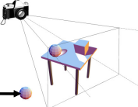

A **clipping algorithm** skips these objects making rendering more efficient.

#### 5) Screen Mapping

Only the **clipped** primitives inside the view volume are passed to this stage.

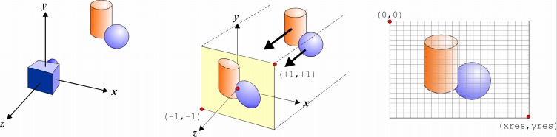

Coordinates are in **3D**.

The $x$ and $y$ coordinates of each primitive are transformed to for **screen coordinates**.

### Rasteriser Stage

Given the **transformed** and **projected** vertices with their associated **shading data** from the geometry stage.

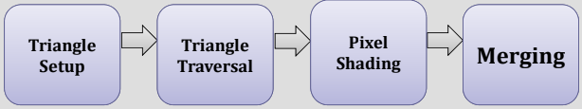

The goal of the rasteriser stage is to compute and set colours for the **pixels** covered by the object.

**Rasterisation** converts from 3D vertices in screen-space to **pixels** on the screen.

#### 1) Triangle Setup

Vertices are collected and **converted into triangles**.

Information is generated that will allow later stages to accurately **generate the attributes** of every pixel associated with the triangle.

#### 2) Triangle Traversal

Decides which pixels are inside a triangle.

Each pixel that has its **center covered** by the triangle is checked.

A **fragment** is generated for the part of the pixel that overlaps the triangle.

Triangle vertices are **interpolated**.

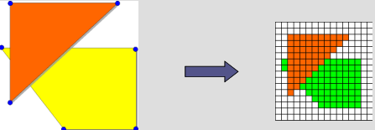

#### 3) Pixel Shading

Performs **per-pixel shading** computations.

The end result is one or more colours to be passed to the next stage.

Executed by **programmable GPU cores**.

**Texturing** is employed here.

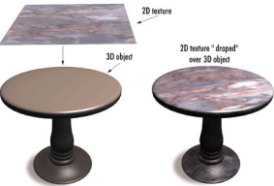

#### 4) Merging

Information for each pixel is stored in the **colour buffer**, which is a rectangular array of colours.

The stage combines the **fragment colour** produced by the shading stage with the **colour currently stored** in the buffer.

This stage is also responsibility for resolving **visibility** with the **z-buffer**.

### Z-Buffer

The z-buffer is arranged as a 2D array with one element for each screen pixel.

It stores the $z$ value from the camera to the currently closest primitive.

If another object of the scene must be rendered in the **same pixel**, the method compares their depths and chooses the **closest one** to the observer.

The chosen depth is then saved to the z-buffer, replacing the old one.

|  |  |
| --- | --- |

**Z-buffer fighting** can occur if the difference in depth between objects is tiny.

The lack of precision causes objects to flicker.

### Double Buffering

The screen displays the contents of the **colour buffer**.

To avoid perception of primitives being rasterised, double buffering is used.

Rendering takes place off screen in a **back buffer**.

Once complete, the contents are swapped with the **front buffer**.

### OpenGL Coordinates

| OpenGL uses a **4-component vector** to represent a vertex.  This is known as a **homogeneous coordinate system**.  Usually $w=1$.  In 2D space, $z=0$. |  |
| --- | --- |

# 03a Geometric Transformations

**Linear algebra** is the cornerstone of computer graphics.

We need to be able to manipulate:

1. Points
2. Vectors

These form the basics of all geometric objects and operations.

**Geometric operations** (scale, rotate, translate) are defined using **matrix transformations**.

**Optical effects** (reflect, refract) are defined using **vector algebra**.

### Coordinate Systems

By convention, we usually employ a **Cartesian basis**:

* Basis vectors are **mutually orthogonal** and **unit length**.
* Basis vectors are named $x$, $y$ and $z$.

We need to define the relationship between these three vectors.

There are two possibilities:

1. **Right-handed systems**: [OpenGL] $z$ 
    comes **out** of the page
2. **Left-handed systems**: $z$ 
    goes **in** to the page

|  |  |  |
| --- | --- | --- |

### Conventions

Vector quantities are denoted as $v$ or $\vec{v}$.

Each vector is defined with respect to a set of **basis vectors**.

We will use **column-format vectors**:

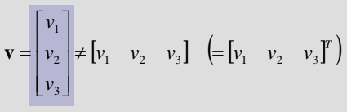

### Row vs. Column Formats

The two formats are fundamentally different:

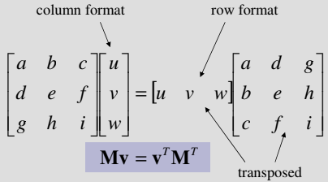

|  |  |
| --- | --- |

In **GLSL**:

| mat3 m; vec3 v;  mat3 u = m * v; |
| --- |

### Vectors & Points

Although vectors and points are often used interchangeably in graphics texts, it is important to distinguish them:

1. **Vectors** represent **directions**.
2. **Points** represent **positions**.

Both are meaningless without reference to a **coordinate system**:

1. Vectors require a set of **basis vectors**.
2. Points require an **origin** and a **vector space**.

|  |  |
| --- | --- |

### Computer Graphics Problems

Much of graphics concerns itself with the problem of displaying **3D objects** in a **2D screen**.

We want to be able to do the following to our objects:

* **Rotate**, **translate** & **scale**.
* View them from arbitrary **points of view**.
* View them in **perspective**.

We want to display objects in coordinate systems that are convenient for us, and to be able to **reuse** object descriptions.

### Matrices

If you want to rotate many vertices about some axis by multiplying each vertex by several matrices, you can instead **pre-multiply** the matrices.

You can then multiply each vertex by the resulting matrix.

**Addition**:



**Multiplication**:



Matrix multiplication is **not commutative** i.e. $AB≠BA$.

If $AB=AC$, it does **not** follow that $B=C$.

Matrix multiplication is **associative** and **distributive**:

1. $(AB)C=A(BC)$*(associativity)*
2. $A(B+C)=AB+AC$*(distributivity)*
3. $(A+B)C=AC+BC$*(distributivity)*

The **transpose $A^{T}$** of a matrix $A$ is one whose **rows** are switched with its **columns**.

## Geometric Transformations

Many geometric transformations are **linear** and can be represented as a **matrix multiplication**.

A function $f$ is linear *iff*:

$f(αx+βy)=αf(x)+βf(y)$

To transform a line, we transform the **endpoints**.

Points between are **affine combinations** of the transformed endpoints.

Given a line between points $P$ and $Q$, points along the transformed line are affine combinations of transformed $P'$ and $Q'$.

$L(t)=P+t(Q-P)$

$L'(t)=P'+t(Q'-P')$

### Homogeneous Coordinates

The basis of the homogeneous coordinate system is the set of $n$**basis vectors** and the **origin position**:

$v_{1},v_{2},...v_{n}$ and $P_{0}$

All points and vectors are therefore compactly represented using their coordinates:

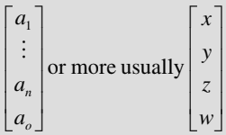

**Vectors** have **no positional information** and are represented using $a_{0}=0$.

**Points** are represented with $a_{0}=1$.

$\vec{v}=a_{1}v_{1}+...+a_{n}v_{n}+0$

$P=a_{1}v_{1}+...+a_{n}v_{n}+P_{0}$

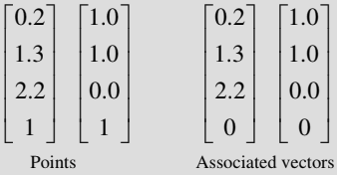

Using this scheme, every rotation, translation and scaling operation can be represented by a **matrix multiplication**. Any **combination** of the operations corresponds to the **products** of the corresponding matrices.

Using homogeneous coordinates allows us to treat translation in the **same way** as rotation and scaling.

### Translation

A **translation** is a displacement in a particular direction.

They are defined by specifying the displacements $a$, $b$ and $c$.

$x'=x+a$

$y'=y+b$

$z'=z+c$

Translations only apply to **points**, never vectors.

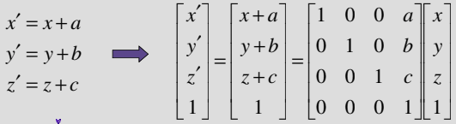

Translations are independent, and can be performed in **any order** (including all at once).

### Scaling

Scaling allows us to make models **larger** or **smaller**.

If we multiply all of our coordinates by $\frac{1}{3}$, then we get a model that is $\frac{1}{3}$ of the size.

However, the **coordinates** are scaled as well.

In order to prevent this, we:

1. **Translate** to origin.
2. **Scale**.
3. **Translate** back.

Generally we centre the scaling at the **origin**:

$x'=s_{x}x$

$y'=s_{y}y$

$z'=s_{z}z$

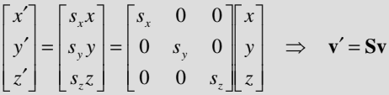

We would also like to scale points, thus we need a **homogeneous transformation** for consistency:

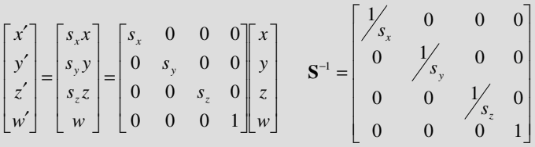

### Rotation

A **rotation** turns about a point $(a,b)$ through an angle $θ$.

Generally, rotations are **anti-clockwise** about the **origin**.

For example, using the $z$-axis as the axis of rotation the equations are:

$x'=x cosθ-y sinθ$

$y'=x sinθ-y cosθ$

$z'=z$

To rotate about an axis:

1. Put your eye on that axis in the **positive direction**, and **look towards the origin**.
2. A **positive rotation** corresponds to a **counter-clockwise** rotation.

Examples:

|  | Rotate **positive** on $y$-axis: |
| --- | --- |
| Rotate **positive** on z-axis: | Rotate **negative** on $x$-axis: |

#### Rotation About The $z$-Axis

| $x'=r cos(Φ+θ)=r cos(Φ) cos(θ)-r sin(Φ) sin(θ)$ $y'=r sin(Φ+θ)=r cos(Φ) sin(θ)+r sin(Φ) cos(θ)$ Since $x=r cos(Φ)$ and $y=r sin(Φ)$: $x'=x cos(θ)-y sin(θ)$ $y'=x sin(θ)+y cos(θ)$ |  |
| --- | --- |

Rotation in the clockwise direction is the **inverse** of rotation in the counterclockwise direction, and vise-versa.

**2D** rotation of $θ$ about origin:

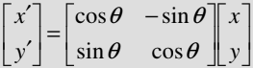

**3D** homogeneous rotations:

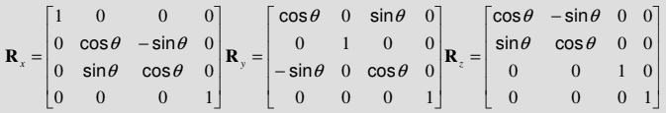

**Note**:

There is a difference for the rotation about $y$ due to the right-handed system (RHS).

**Note**:

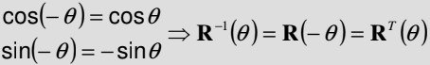

## Combining Rotation, Translation & Scaling

It is often advantageous to **combine** various transformations to form a more complex transformation.

Things get complicated if we use algebra, so instead we use **matrices**.

### Homogeneous Coordinates

Using this scheme allows us to represent every rotation, translation and scaling operation by a **matrix multiplication**.

Any **combination** of the operations corresponds to the **products** of the corresponding matrices.

### Affine Transformations

|  | All **affine transformations** are combinations of rotations, scaling and translation operations. |
| --- | --- |

### Transformation Composition I

It is common for graphics programs to apply **more than one** transformation to an object.

**Example**:

Take a vector $v_{1}$, scale ($S$) it and then rotate ($R$) it.

$v_{2}=Sv_{1}$

$v_{3}=Rv_{2}$

Since matrix multiplication is **associative**, we can instead say $v_{3}=(RS)v_{1}$.

We can therefore recreate the effect of the two matrices by **multiplying them together** first.

More complex transformations can be created by **concatenating** / **composing** individual transformations together:

$M=T∘R∘S∘T=TRST$

$v'=T[R[S[Tv]]]=Mv$

Matrix multiplication is **noncommutative**, therefore order is vital.

### Rotation About a Point

We can create an **affine transformation** representing rotation about a point $P_{R}$:

$M=T(P_{R})R(θ)T(-P_{R})$

In other words (we order the operations from **right → left**):

1. $T(-P_{R})$ Translate to origin
2. $R(θ)$ Rotate about origin
3. $T(P_{R})$ Translate back to original location

### Transformation Composition II

To rotate about a point $P$ by $q$ degrees in the $xy$ plane:

$M=T(P)R(θ)T(-P)$

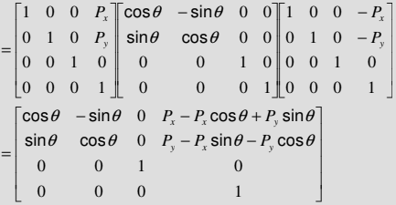

### Euler Angles

**Euler angles** represent the angles of rotation about the coordinate axes required to achieve a **given orientation $(θ_{x},θ_{y},θ_{z})$** .

The resulting matrix is:

$M=R(θ_{x})R(θ_{y})R(θ_{z})$

Any required rotation may be described as a **composition of three rotations** about the **coordinate axes**.

**NB**: Rotation does **not** commute. Order is important.

### Rotational DOF (Degrees of Freedom)

These are sometimes referred to as **roll**, **pitch** and **yaw**:

|  |  |
| --- | --- |

### OpenGL Uniforms

We use **uniforms** to declare shader input data that **stays the same** e.g. a transformation matrix.

| in vec4 vPosition; // Vertex in the **local** coordinate system. uniform mat4 mM; // Matrix for the pose of the **model**. uniform mat4 mV; // Matrix for the pose of the **camera**. uniform mat4 mP; // **Projection** matrix (perspective).  void **main**() {  // vPosition = old position, gl_Position = new position.  gl_Position = mP * mV * mM * vPosition; } |
| --- |

## General Rotation

What do we do if we want to rotate about an axis **other** than the three principal axes?

1. Perform one or two rotations about the principal axes in order to align with the $z$-axis.
2. Rotate about the $z$-axis.
3. Undo the rotations in *step 1*.

### Rotation About An Arbitrary Axis

A frequent requirement is to determine the **matrix** for rotation about a given axis.

Such rotations have **3 degrees of freedom**:

* 2 for spherical angles specifying **axis orientation**.
* 1 for **twist** about the **rotation axis**.

We assume that the axis is defined by points $P$ and $Q$.

The **pivot point** is $P$.

The **rotation vector** is $v=\frac{P-Q}{|P-Q|}$.

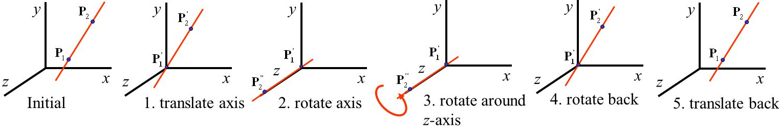

Steps:

1. Translate the **pivot point** of the axis to the **origin**. $T(-P)$
2. Rotate the axis and object so that the axis **lines up** with $z$.  
   e.g. $R(θ_{y}) R(θ_{x})$
3. Rotate about $z$ by the required angle $θ$: $R(θ)$
4. **Undo** the first two rotations to bring us back to the **original rotation**. $R(-θ_{x})R(-θ_{y})$
5. Translate back to the **original position**: $T(P)$

The final **rotation matrix** is: $M=T(P) R(-θ_{y}) R(-θ_{x}) R(θ) R(θ_{x}) R(θ_{y}) T(-P)$

### Rotation About An Axis

We need the **Euler angles $θ_{x}$** and $θ_{y}$ which will orient the rotation axis along the $z$-axis.

We determine these using simple **trigonometry**.

#### Aligning With The $z$-Axis

| We rotate the line segment into the plane $y=0$. $r=\sqrt{v_{x}^{2}+v_{z}^{2}}$ $cos(θ_{x})=r$ $sin(θ_{x})=v_{y}$ $cos(θ_{y})=\frac{v_{z}}{r}$ $sin(θ_{y})=\frac{v_{x}}{r}$ |  |
| --- | --- |

The rotation about the $x$-axis is anti-clockwise, but the $y$-axis rotation is clockwise.

Therefore the required $y$-axis rotation is $-θ_{y}$:

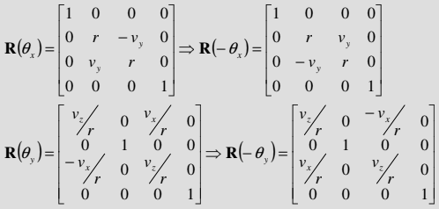

$M=T(P) R(θ_{y}) R(-θ_{x}) R(θ) R(θ_{x}) R(-θ_{y}) T(-P)$

# 03b Linear Algebra for Graphics

Vectors are **equivalent** if they both have the same:

1. Length
2. Direction

Equivalent vectors are regarded as equal even if they are located in **different positions**.

### Vector Addition

**Head-to-tail** rule:

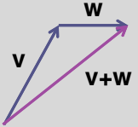

### Negative Vectors

The negative of a vector $v$ has the same magnitude but opposite direction.

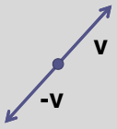

### Vector Subtraction

| $v-w=v+(-w)$ | **Tail-to-tail** rule: |
| --- | --- |

### The Parallelogram Law

Addition and subtraction of vectors follows the **parallelogram law** in 2D.

In higher dimensions, they follow the **parallelepiped law**.

| **Addition**: |  |  |
| --- | --- | --- |

**Subtraction**:

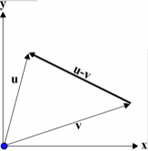

### Vector Multiplication

Multiplying a vector by a **scalar** scales the vector’s **length** appropriately.

It does **not** affect its direction.

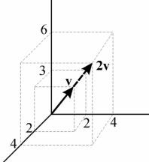

Vectors that are scalar multiples of each other are **parallel**.

### Linear Combinations

The **linear combination** of a set of vectors is the **sum of scalar multiples** of those vectors:

$u=a_{1}v_{1}+a_{2}v_{2}+...+a_{n}v_{n}$

Fixing vectors $v_{i}$ yields an infinite number of $u$ depending on the scalars $a_{i}$ where:

* $u$ is the **span** of the vectors $v_{i}$.
* $v_{i}$ are **basis vectors** for the space.

If none of the $v_{i}$ can be created as a linear combination of the others, then the vectors $v_{i}$ are said to be **linearly independent**.

**All** linear combinations contain the **zero vector**.

|  | Linear combinations of **one vector** ⇒ an **infinite line**. |
| --- | --- |
|  | Linear combinations of **two vectors** ⇒ a **plane**. |
|  | Linear combinations of **three vectors** ⇒ a **3D volume**. $v$   is linear combination of the basis vectors $x$, $y$ and $z$: |

### Vector Magnitude

The **magnitude** or **norm** of a vector $v$ of dimension $n$ is given by the standard **Euclidean distance metric**:

$||v||=\sqrt{v_{1}^{2}+v_{2}^{2}+...+v_{n}^{2}}$

For example:

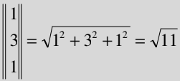

Vectors of **length one** (unit vectors) are often termed **normal** or **normalised vectors**.

### Normalised Vectors

When describing **direction** we use **normalised vectors**.

We normalise a vector by dividing by its **magnitude**:

$v'=\frac{v}{||v||}=\frac{v}{\sqrt{v_{1}^{2}+v_{2}^{2}+...+v_{n}^{2}}}$

**Examples**:

| Let $u=[2,-2,3]$, $v=[1,-3,4]$ and . |
| --- |

### Dot Product

A dot product of two vectors returns a **scalar**.

It calculates **angles**.

*“It returns the length of the projection $A$ onto .”*

|  |  |  |
| --- | --- | --- |

The dot product (inner product) is defined as:

$u⋅v=\sum_{i}{}u_{i}v_{i}$

$u⋅v=u^{T}v$

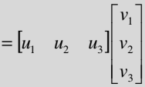

$=u_{1}v_{1}+u_{2}v_{2}+u_{3}v_{3}$

**Note**:

$u⋅u=u_{1}^{2}+u_{2}^{2}+u_{3}^{2}={||u||}^{2}$

Therefore, we can also define **magnitude** in terms of the dot product operator:

$||u||=\sqrt{u⋅u}$

The dot product operator is **commutative**.

| If **both** vectors are **normalised**, then the dot product defines the **cosine** of the angle between vectors: $u⋅v=cos θ$ In general: |  |
| --- | --- |
| If **one** of the vectors is normalised, then the dot product defines the **projection of the other** onto it (perpendicularly).  In this example, $a$ is positive and $b$ is negative. $a=u⋅v$ $b=u⋅w$ Note that if both vectors are pointing in the **same direction** then the dot product is **positive**. |  |
| If $θ=90°$ then the dot product $=0$.  The projection of one onto the other has zero length ⇒ The vectors are **orthogonal**.  Similarly, if $θ<90°$ then the dot product $<0$. |  |

#### Dot Product in Computer Graphics

The dot product can be used to find:

* Is an angle between two vectors acute, a right angle or obtuse?
* Is a polygon facing towards or away from the camera?

A problem with the dot product is that arccosine always returns a **positive number**.

The dot product is **directionless**, giving you the same result for $A⋅B$ as $B⋅A$.

### Normals

**Polygons** are planar regions bounded by $n$ edges connecting $n$ points / vertices.

For lighting and viewing calculations, we need to define the **normal** to a polygon.

The normal distinguishes the **front face** from the back face of a polygon.

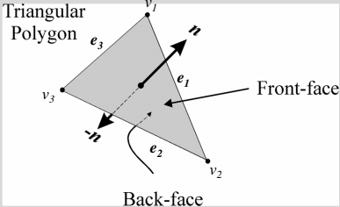

The plane of the polygon divides 3D space into two **half-spaces**:

1. **In front** of the polygon.
2. **Behind** the polygon.

To determine the side that a polygon lies on:

$d=n⋅(P-v_{i})$

The values of $d$ correspond as follows:

1. $d<0$ ⇒ $P$ lies **behind** the polygon.
2. $d=0$ ⇒ $P$ lies **on** the polygon.
3. $d>0$ ⇒ $P$ lies **in front of** the polygon.

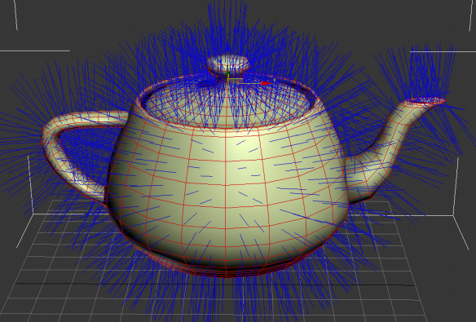

### Cross Product

The cross product of two vectors returns a **vector**.

It calculates **direction**.

The cross product returns a vector that is **orthogonal** (perpendicular) to the plane formed by the two input vectors.

The cross product is used for:

1. Defining **orientation**
2. Constructing **coordinate axes**

| It is defined as: |  |
| --- | --- |

$A×B≠B×A$

If $w=u×v$:

$||u×v||=||u|| ||v|| sin θ$

$u×v=w ||u|| ||v|| sin θ$

|  | Right-Handed Coordinate System |
| --- | --- |

The cross product is **anticommutative**:

$u×v=-(v×u)$

The cross product is **not associative**:

$u×(v×w)≠(u×v)×w$

Therefore the direction of the resulting vector is defined by **operand order**.

#### Cross Product in Computer Graphics

The classic use of the cross product is figuring out the **normal vector** of a polygon.

This is fundamental to calculating which polygons are facing the camera.

This process determines which polygons are drawn and ignored.

| **Dot Product** | **Cross Product** |
| --- | --- |
| * Returns a **scalar**. * Calculates **angles**. $A⋅B=B⋅A$ | * Returns a **vector**. * Calculates **direction**. $A×B≠B×A$ |

### Coordinate Systems

The Cartesian coordinate system is one of infinitely many possible orthonormal bases.

The **global coordinate system** in graphics is the **canonical coordinate system**.

It is special because $x$, $y$, $z$ and the origin are never explicitly stored.

If we want to use **another** coordinate system with origin $p$ and orthonormal basis vectors $u$, $v$ and $w$, then we **do** store these vectors explicitly.

| In this example, the coordinate system associated with the plane is the **local coordinate system**. |  |
| --- | --- |

### Change of Basis

If we know $s$ that is defined w.r.t. basis $xyz$, then we can determine $t$ which is the same vector defined w.r.t. basis $uvw$:

* $t_{u}$ is the projected distance of $s$ onto $u$.
* $t_{v}$ is the projected distance of $s$ onto $v$.
* $t_{w}$ is the projected distance of $s$ onto $w$.

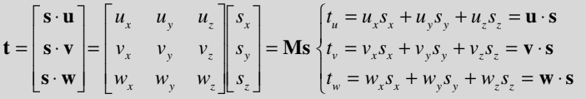

The **transformation matrix $M$**  allows us to transform a vector from **one basis to another**.

Many common geometric operations can be expressed as a transformation matrix.

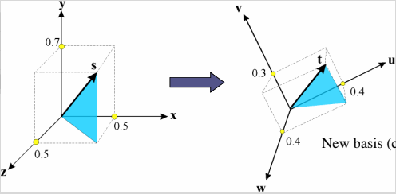

|  |  |  |
| --- | --- | --- |

Normally the vectors forming the basis of a coordinate system are:

1. Unit length.
2. Mutually orthogonal.

A basis is said to be **orthonormal** ⇒ $M=M^{-1}$:

* True for all **rotation matrices**.
* Not true for **scaling transformations**.

Therefore if we have a vector $t$ defined w.r.t. basis $uvw$, then the vector $s$ w.r.t. basis $xyz$ is given by:

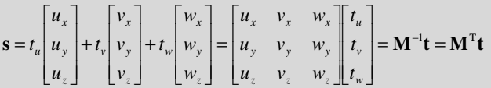

### Transformation

Changing basis is geometrically equivalent to **transformation**.

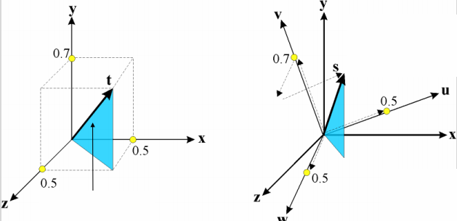

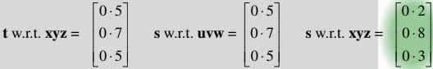

### Affine Spaces

Vectors define **direction** and **magnitude** only.

To encode position we need to **fix** the origin.

An **affine space** is:

1. A **set of points**
2. With an associated **vector space**
3. With the **operations**:
   1. Difference
   2. Translate

| Points are related by vectors: $u=P-Q$ $P=Q+u$ |  |
| --- | --- |

### Normals & Polygons

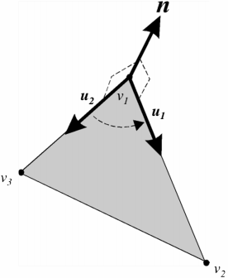

# 04 Viewing

### Transformation Pipeline

Transformations take us from one **space** to another.

All of our transforms are $4×4$ matrices.

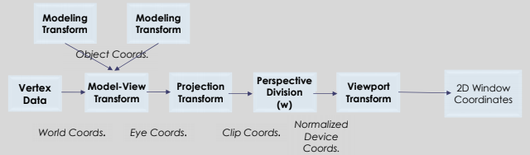

### Camera Modelling

Types of transformation:

1. **Projection** transformations adjust the **lens** of the camera.
2. **Viewing** transformations define the **position** and **orientation** of the viewing volume in the world.
3. **Modelling** transformations move the **model**.
4. **Viewport** transformations enlarge / reduce the physical photograph.

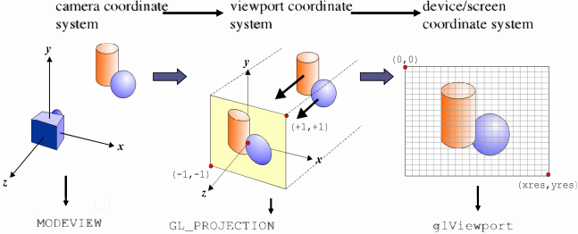

### Model Matrix

When creating a triangle or loading a mesh from a file, it has some $(0,0,0)$**origin** which is local to that mesh.

In order to translate, rotate or scale to position the model in a virtual world, we multiply its points with a **model matrix** (world matrix).

| mat4 M = T * R * S; // translation * rotation * scale vec4 pos_wor = M * vec4(pos_loc, 1.0); |
| --- |

### 3D to 2D Projection

The type of projection depends on a number of factors:

1. **Location** and **orientation** of the viewing plane / **viewport**.
2. **Direction of projection** which is described by a vector.
3. Projection type.

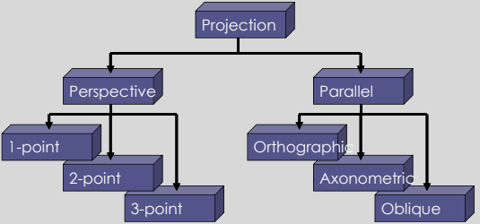

### Orthogonal Projection

Orthogonal projections are **parallel** projections onto the view plane.

Usually the view plane is **axis-aligned** (often ):

|  |  |
| --- | --- |

The projection is:

1. **Orthographic** if the object is **axis-aligned**.
2. **Axonometric** otherwise.

| **Orthographic** | **Axonometric** |
| --- | --- |
|  |  |

An **axonometric projection** is a type of orthographic projection used to create a **pictorial drawing** of an object. The object is **rotated** along one (or more) of its axes relative to the plane of projection.

If the projection plane intersects the principle axes at the **same distance** from the origin, then the projection is **isometric**.

| **Isometric** |
| --- |
|  |

In OpenGL, the default projection matrix is an **identity matrix**, or equivalently:

| // ortho(left, right, bottom, top, near, far) mat4 N = ortho(-1.0, 1.0, -1.0, 1.0, -1.0, 1.0); |
| --- |

This is a **canonical view volume**:

* Points within the cube are mapped to the same cube.
* Points outside the cube remain outside ⇒ **clipped**.

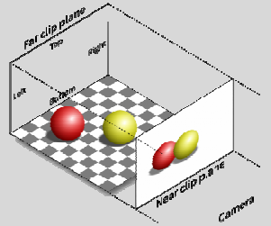

**Note**:

We always view in the $-z$ direction. We need to transform the world in order to view in other arbitrary directions.

#### Orthogonal Projection Matrix

The projection **linearly** maps view-space coordinates into clip-space coordinates.

We transform this canonical view volume to the cube centered at the origin, with sides of length 2.

We need to **translate to the origin** and **scale the sides** to have a length of 2:

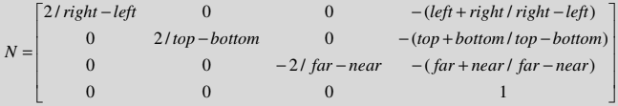

### Perspective Projection

| **Parallel / Orthogonal Projection** | **Perspective Projection** |
| --- | --- |
| * Keeps parallel lines parallel. * Preserves **size** and **shape** of planar objects. * **Unrealistic**. * Used in **architecture**. * Represents less-natural images. * Simple. | * Objects further away appear **smaller**. * More **realistic**. |

Perspective projections are **more complex** and exhibit **foreshortening**.

**Foreshortening**:

Parallel lines appear to **converge** at points.

| Parameters:   1. **Center** of projection (COP) 2. **Field of view** (FOV) 3. **Projection** direction 4. **Up** direction |  |
| --- | --- |

| Consider a perspective projection with:   * The **viewpoint** at the **origin**. * A **viewing direction** oriented along the positive $z$-axis. * The **view plane** located at $z=-d$. $\frac{y}{z}=\frac{y_{p}}{d}$ $⇒y_{p}=\frac{y}{z/d}$ *(Non-uniform shortening)* |  |
| --- | --- |

A similar construction for $x_{p}$:

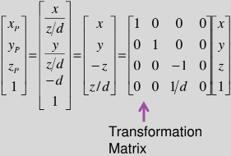

### Homogeneous Coordinates

| Consider the matrix: | It transforms the point: | Divide by $w$ to return to the original 3D: |
| --- | --- | --- |

### Perspective Projections

Although perspective transformations preserve lines, they are not **affine**.

$(x,y,z)→(x_{p},y_{p},z_{p})$

The transformation is **irreversible**:

* All points along a projection project onto the **same point**.
* We **cannot** recover a point from its projection.

Depending on the application, we can use different mechanisms to specify a perspective view:

1. lookAt()
2. frustrum()
3. perspective()

The **FOV angle** may be derived if the distance to the **viewing plane** is known.

The **viewing direction** may be obtained if a **point** in the scene is identified that we wish to look at.

#### Frustum

| mat4 **frustum**(xmin, xmax, ymin, ymax, zmin, zmax); |
| --- |

zmin and zmax are specified as positive distances along $-z$.

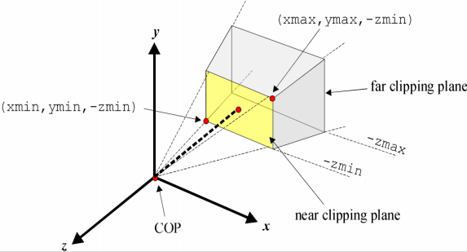

It is not necessary to have a **symmetric frustum** like:

| frustum(-1.0, 1.0, -1.0, 1.0, 5.0, 50.0); |
| --- |

Asymmetric frustums introduce **obliqueness** into the projection.

#### Perspective

| mat4 **perspective**(fov, aspect, near, far); |
| --- |

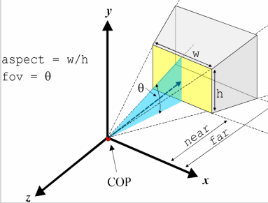

$\frac{h/2}{near}=tan\frac{θ}{2}$

$⇒h=2 near tan\frac{θ}{2}$

This function simplifies the specification of perspective views. It only allows the creation of **symmetric frustums**.

Properties:

* Viewpoint is at the **origin**.
* Viewing direction is the $-z$-axis.
* Field of view angle must be in the range 0-180°.

The aspect parameter **eliminates distortion** by matching the viewport width and height.

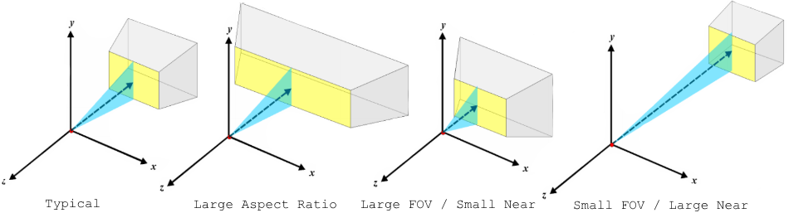

### Lens Configurations

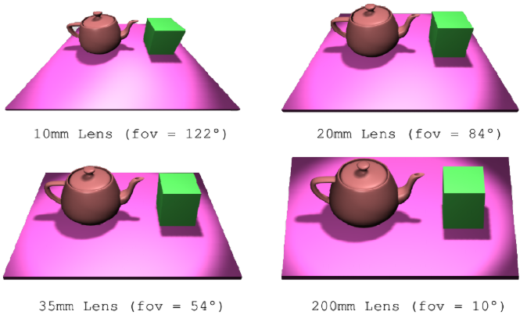

### Positioning The Camera

In previous projections we had a **fixed** origin and projection direction.

To obtain arbitrary camera orientations and positions, we manipulate the **view matrix**.

This positions the camera w.r.t. the model.

If we wish to position the camera at $(10,2,10)$ w.r.t. the world, we have two possibilities:

1. **Transform the world** prior to the creation of objects using translation and rotation matrices:  
   translate(-10, -2, -10);
2. Use the **lookAt function** to position the camera with respect to the world coordinate system:  
   lookAt(10, 2, 10, ...);

Both of these are equivalent.

### View Matrix

Objects are positioned in a scene / world with a $(0,0,0)$ origin.

We want to show the view from a camera, moving through the virtual world.

We multiply the **world-space** points by a **view** matrix to get to **eye-space**.

| mat4 V = R * T; // 1. Inverse of camera position and angle. mat4 V = lookAt(pos, target, up); // Or 2.  vec4 pos_eye = V * pos_world; |
| --- |

### Positioning The Camera

| lookAt(eyeX, eyeY, lookX, lookY, lookZ, upX, upY, upZ); |
| --- |

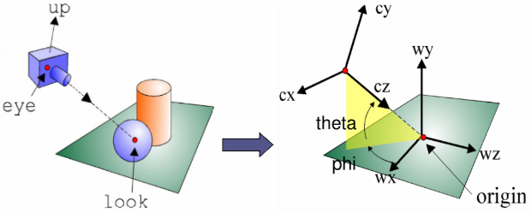

This is equivalent to:

| translate(-eyeX, -eyeY, -eyeZ); rotate(theta, 1.0, 0.0, 0.0); rotate(phi, 0.0, 1.0, 0.0); |
| --- |

### Up Vector

The **up vector** tells us which direction is up.

It must be **perpendicular** to the line of sight.

|  |  |
| --- | --- |

### LookAt

The lookAt function is useful when **panning** across a scene.

### Viewport

The **projection matrix** defines the mapping from a 3D world coordinate → 2D viewport coordinate.

The viewport extents are defined as a parameter of the projection

| frustum(left, right, bottom, top, near, far) |  |
| --- | --- |
| perspective(fov, aspectRatio, near, far) $height=near tan\frac{fov}{2}$ $width=height×aspectRatio$ |  |

### Viewport to Window Transformation

We need to associate the 2D viewport coordinate system with the window coordinate system to determine the **correct pixel** associated with each vertex.

| **Normalised Device Coordinates** | **Window Coordinates** |
| --- | --- |
|  |  |

We use an **affine planar transformation**.

After the projection to the view-plane, all points $([-1,+1], [-1,+1])$ are transformed to normalised device coordinates:

$x_{n}=2\left(\frac{x_{p}-x_{min}}{x_{max}-x_{min}}\right)-1$

$y_{n}=2\left(\frac{y_{p}-y_{min}}{y_{max}-y_{min}}\right)-1$

We use glViewport to relate coordinate systems:

| void **glViewport**(int x, int y, int width, int height); |
| --- |

Width and height are the dimensions of the viewport:

$x_{w}=(x_{n}+1)(\frac{width}{2})+x$

$y_{w}=(y_{n}+1)(\frac{height}{2})+y$

### Aspect Ratio

The aspect ratio defines the relationship between the **width** and **height** of an image.

Using a perspective matrix, a viewport aspect ratio can be provided.

Otherwise, the aspect ratio is a function of the supplied **viewport width** and **height**.

Unmatched window and viewport aspect ratios will cause **affine distortion**:

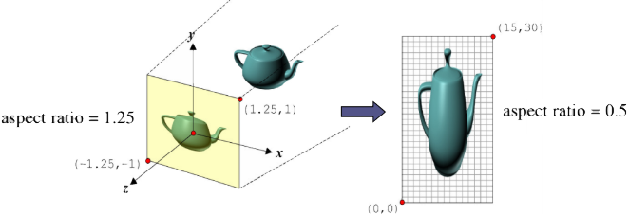

### Multiple Projections

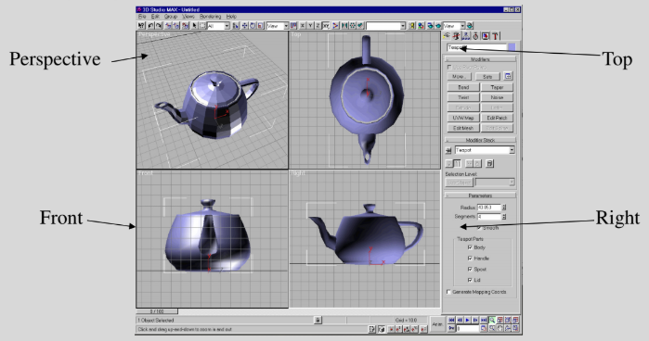

# 05 Hierarchical Modelling

## Character Animation

| Animating a character model described as a polygon mesh by **moving each vertex** is **impractical**.  Instead, we specify the motion of characters through the movement of an internal articulated **skeleton**. |  |
| --- | --- |

| Rigid Body Limitations  When human joints bend, the body shape bends as well. There are **no distinct parts**.  We cannot represent human joints with **rigid bodies**, else the pieces would **separate**. |  |
| --- | --- |

### Relative Motion

We are interested in animating objects whose motion is **relative** to another.

Such a sequence is called a **motion hierarchy**.

Components of a hierarchy represent objects that are **physically connected** / linked.

In some cases, motion can be restricted:

* Reduced dimensionality.
* Hierarchy enforcing constraints.

There are two approaches for **animating figures** defined by hierarchies:

1. **Forward** kinematics
2. **Inverse** kinematics

### Degrees of Freedom

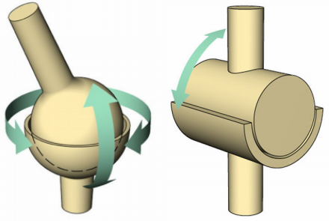

### Model Transformations

A **local frame view** is usually adopted as it extends naturally to the specification of **hierarchical model frames**.

This allows the creation of **jointed assemblies**: articulated figures (e.g. animals, robots etc).

In a hierarchical model, each sub-component has its own **local frame**.

Changes to the **parent frame** are propagated down to the **child frames**.

This simplifies the specification of animation.

### Hierarchical Transformations

For geometries with an implicit hierarchy, we wish to associate **local frames** with **sub-objects** in the assembly.

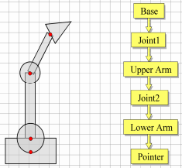

**Parent-child** frames are related via a **transformation**.

Transformation linkage is described as a **tree**.

Each node has its own **local coordinate system**.

Hierarchical transformation allows **independent control** over subparts of an assembly:

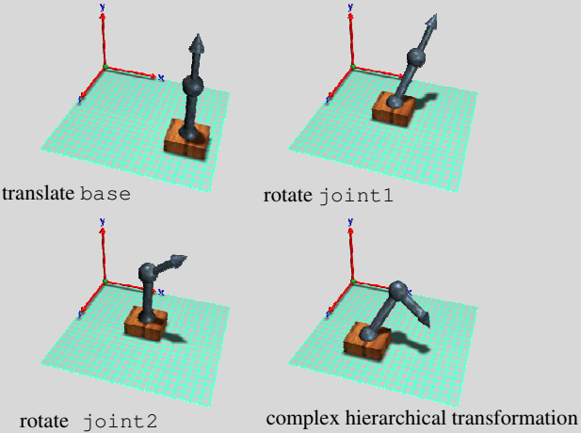

#### OpenGL Implementation

| local1 = identity_mat4(); local1 = rotate(base_orientation) * local1; local1 = translate(bx, by, bz) * local1; global1 = local1;  updateUniformVariables(); drawBase();  local2 = identity_mat4(); local2 = rotate(joint1_orientation) * local2; local2 = translate(0, j1y, 0) * local2; global2 = local1 * local2;  updateUniformVariables(); drawJoint1();  local3 = identity_mat4(); local3 = rotate(upperArm_orientation) * local3; local3 = translate(0, uay, 0) * local3; global3 = local1 * local2 * local3;  updateUniformVariables(); drawUpperArm(); |  |
| --- | --- |

This example has simple one-to-one parent-child linkages.

In general there may be **many** child frames derived from a single parent frame.

We need to remember the parent frame and return to it when creating new children. We store a global transformation as we go.

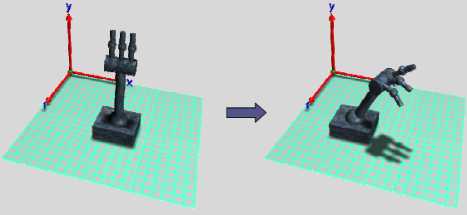

Each finger is a **child** of the wrist. This gives **independent control** over the orientation of the fingers relative to the wrist.

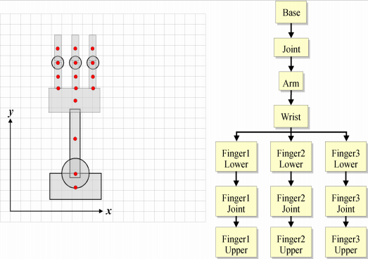

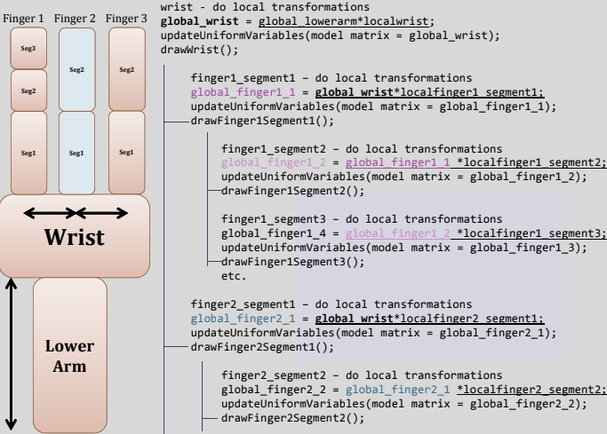

Link to [Part Two](https://docs.google.com/document/d/1gM4m6LacAK0v8tCtG-s2c_XbguPq9lktMZ-TtIwpaXg)